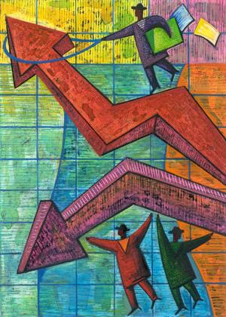

|  |
| --- |
| **Principles and Practices** |

|  |  |
| --- | --- |
| 2018 | Market and mixed economy |

|  |  |  |  |
| --- | --- | --- | --- |
| ***Key Learner Outcomes:*** | | ***Yes*** | ***No*** |
| 9.2.4.1 | 1. ***List*** the principles of a market economy. |  |  |
| 9.2.4.2 | 1. ***Summarize*** why governments intervene in a market economy. |  |  |
| 9.2.4.3 | 1. ***Explain*** why Canada is viewed as having a mixed economy. |  |  |
| 9.2.4.4 | 1. ***Compare*** the role of the consumer in market and mixed economies. |  |  |
| 9.2.4.5 | 1. ***Determine*** the extent of consumer action on individual and collective identity. |  |  |
| 9.2.4.6 | 1. ***Analyze*** the impact of labour unions on market and mixed economies |  |  |
| 9.2.4.7a | 1. ***Outline*** the similarities and differences of how Canadian and American governments intervene in their economies. |  |  |
| 9.2.4.7b | 1. ***Outline*** the similarities and differences of why Canadian and   American governments intervene in their economies |  |  |
| 9.2.4.8 | 1. ***Distinguish*** the different ways Canada and the United States answer the basic economic questions of scarcity. |  |  |

|  |  |
| --- | --- |
| **Formative Assessment:** | **Evidence:** |
| Market and Mixed Economy: Vocabulary | **N S P E** |
| Economic Basics | **N S P E** |
| Factors of Production | **N S P E** |
| Economic Systems | **N S P E** |
| Public Good | **N S P E** |
|  |  |
|  |  |

|  |  |
| --- | --- |
| **Summative Assessment:** | **Evidence:** |
|  | **/18** |
|  | **/24** |
| Market and Mixed Economy: Multiple Choice Test | **/20** |

**Chapter Vocabulary N S P E**

Use pages 194 – 217of your textbook, the glossary and a dictionary define the following terms.

1. Capital –
2. Competition –
3. Consumers –
4. Crown corporation –
5. Demand –
6. Economics –
7. Economic system –
8. Economy –
9. Labour –
10. Land –
11. Privately owned –
12. Producers –
13. Public good –
14. Publicly owned –
15. Quality of life –
16. Scarcity –
17. Shift left –
18. Shift right –
19. Supply –

**Economic Basics N S P E**

Complete the following based on classroom discussion and your individual opinion.

|  |  |
| --- | --- |
| **Wants:** | **Needs:** |
|  |  |

Answer the following questions based to your responses above.

1. Do you always get what you want? Explain why or why not.
2. What is the single greatest factor limiting your ability to get everything you want? Explain.

**Factors of Production N S P E**

Complete the following chart using page 203 of your text

|  |  |  |
| --- | --- | --- |
| **Factors of Production** | | |
| **Factor:** | **Description:** | **Graphic:** |
|  |  |  |
|  |  |  |
|  |  |  |

**Economic Systems N S P E**

Label the diagram below based on the in class presentation.

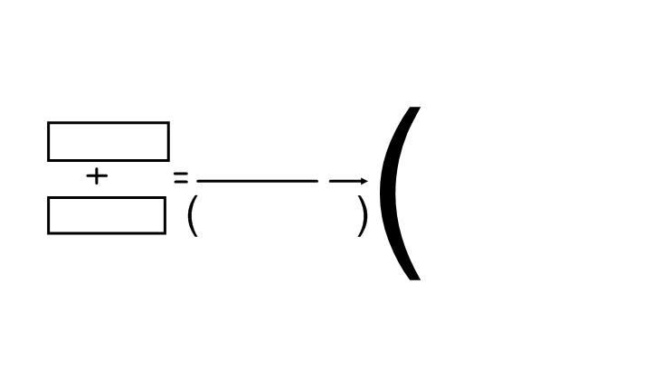

**Word Bank:**

Factors of Production How will it be produced? Limited resources

3 basic economic questions Unlimited wants and needs Scarcity

you can’t have everything Who will it be produced for?

What will be produced?

**Supply and Demand –Notes**

In our market economy, prices are determined by supply and demand.

Supply – the amount available to the consumer.

Demand – what the consumer desire’s to purchase, based on need or want.

Supply represents the producer or manufacturer.

Price Equilibrium Price best price for both the

Consumer and Producer

Demand represents the consumer.

Quantity

**EXAMPLE: DVD / BLUE RAY MOVIES**

Supply – regulated by the producer. Higher price means

more units produced.

Price $15

Equilibrium Price - $12.00

$10

$5 Demand – Regulated by the consumer. Lower price

means more units sold.

1 2 3 4 5 6 7

Quantity (millions sold)

**Graphing Supply and Demand N S P E**

Construct a graph representing the market for motorcycles using the data below. Clearly label both axes, the supply and demand curves, equilibrium, price and quantity. Supply line equals price and quantity supplied. Demand line equals price and quantity demanded.

|  |  |  |
| --- | --- | --- |
| Price (dollars) | Quantity Demanded | Quantity Supplied |
| 4,000 | 100,000 | 0 |
| 6,000 | 80,000 | 20,000 |
| 8,000 | 60,000 | 40,000 |
| 10,000 | 40,000 | 60,000 |
| 12,000 | 20,000 | 80,000 |
| 14,000 | 0 | 100,000 |

What would be the market price of motorcycles?

|  |  |  |  |  |  |  |  |  |  |  |  |  |  |  |  |  |  |  |  |  |  |  |  |  |
| --- | --- | --- | --- | --- | --- | --- | --- | --- | --- | --- | --- | --- | --- | --- | --- | --- | --- | --- | --- | --- | --- | --- | --- | --- |
|  |  |  |  |  |  |  |  |  |  |  |  |  |  |  |  |  |  |  |  |  |  |  |  |  |
|  |  |  |  |  |  |  |  |  |  |  |  |  |  |  |  |  |  |  |  |  |  |  |  |  |
|  |  |  |  |  |  |  |  |  |  |  |  |  |  |  |  |  |  |  |  |  |  |  |  |  |
|  |  |  |  |  |  |  |  |  |  |  |  |  |  |  |  |  |  |  |  |  |  |  |  |  |
|  |  |  |  |  |  |  |  |  |  |  |  |  |  |  |  |  |  |  |  |  |  |  |  |  |
|  |  |  |  |  |  |  |  |  |  |  |  |  |  |  |  |  |  |  |  |  |  |  |  |  |
|  |  |  |  |  |  |  |  |  |  |  |  |  |  |  |  |  |  |  |  |  |  |  |  |  |
|  |  |  |  |  |  |  |  |  |  |  |  |  |  |  |  |  |  |  |  |  |  |  |  |  |
|  |  |  |  |  |  |  |  |  |  |  |  |  |  |  |  |  |  |  |  |  |  |  |  |  |
|  |  |  |  |  |  |  |  |  |  |  |  |  |  |  |  |  |  |  |  |  |  |  |  |  |
|  |  |  |  |  |  |  |  |  |  |  |  |  |  |  |  |  |  |  |  |  |  |  |  |  |
|  |  |  |  |  |  |  |  |  |  |  |  |  |  |  |  |  |  |  |  |  |  |  |  |  |
|  |  |  |  |  |  |  |  |  |  |  |  |  |  |  |  |  |  |  |  |  |  |  |  |  |
|  |  |  |  |  |  |  |  |  |  |  |  |  |  |  |  |  |  |  |  |  |  |  |  |  |
|  |  |  |  |  |  |  |  |  |  |  |  |  |  |  |  |  |  |  |  |  |  |  |  |  |
|  |  |  |  |  |  |  |  |  |  |  |  |  |  |  |  |  |  |  |  |  |  |  |  |  |
|  |  |  |  |  |  |  |  |  |  |  |  |  |  |  |  |  |  |  |  |  |  |  |  |  |
|  |  |  |  |  |  |  |  |  |  |  |  |  |  |  |  |  |  |  |  |  |  |  |  |  |
|  |  |  |  |  |  |  |  |  |  |  |  |  |  |  |  |  |  |  |  |  |  |  |  |  |
|  |  |  |  |  |  |  |  |  |  |  |  |  |  |  |  |  |  |  |  |  |  |  |  |  |
|  |  |  |  |  |  |  |  |  |  |  |  |  |  |  |  |  |  |  |  |  |  |  |  |  |
|  |  |  |  |  |  |  |  |  |  |  |  |  |  |  |  |  |  |  |  |  |  |  |  |  |
|  |  |  |  |  |  |  |  |  |  |  |  |  |  |  |  |  |  |  |  |  |  |  |  |  |
|  |  |  |  |  |  |  |  |  |  |  |  |  |  |  |  |  |  |  |  |  |  |  |  |  |
|  |  |  |  |  |  |  |  |  |  |  |  |  |  |  |  |  |  |  |  |  |  |  |  |  |

**Describing Supply and Demand N S P E**

*Complete the following sentences by circling the correct word or words:*

1. The quantity of a good that producers are willing to offer for sale at a given price is the (demand/supply) of that good.
2. When prices are high, the quantity demanded will tend to be (high/low).
3. An (increase/decrease) in price will tend to result in increased supply.
4. If the price of a good is set above the equilibrium, a (surplus/shortage) will result.
5. Equilibrium price is the price at which the quantity supplied is (greater than/equal to/ less than) the quantity demanded.
6. The quantity demanded for a good will be greater than the quantity supplied if the price of the good is (above/equal to/ below) equilibrium.
7. If the demand for the good drops, the price of that good will usually (drop/ stay the same/ rise).
8. If retailers cannot keep enough product to satisfy their customers, it indicates that the price of the product is (too low/ at equilibrium/ too high).
9. If the market price of a good falls, producers of that good will tend to produce (more/ less) of that good.
10. Prices in a free market system are set by (sellers & buyers/ the market/ the government).

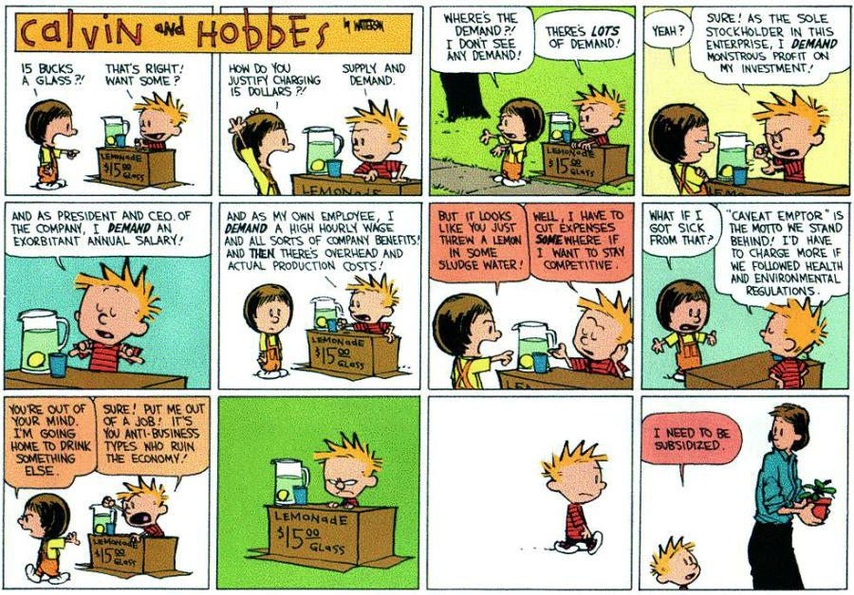

**SUPPLY and DEMAND Political Cartoons**

1. **Study the cartoon below. What is the supply? What is the demand? How is the demand created?**

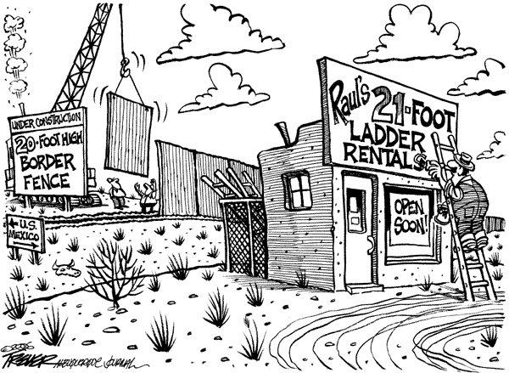

1. **In the cartoon below, when will candy canes be most expensive? When will they be cheapest? Explain both your answers in terms of supply-and-demand.**

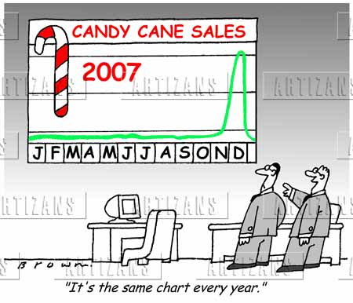

**Economic Systems N S P E**

An economic system is a way to solve the basic problem of scarcity. Different ideas about how best to organize an economy result in different economic systems. Economic systems can be positioned on a continuum (like the one below). An economic system’s position on the continuum is dynamic (changing), and depends on the underlying values of a society and its government.

Complete the continuum using page 204 of your text and the word bank.

**Word Bank:**

more government less government Planned Economy

Canada Market Economy Mixed Economy

Cuba, Soviet Union, China United States

**Economic Systems N S P E** Use pages 204 – 208 of your text to complete.

In your own words, what is an economic system? ________________________________________________________________

________________________________________________________________

________________________________________________________________________________________________________________________________

**THE ECONOMIC CONTINUUM**

|  |  |  |
| --- | --- | --- |
| **Planned Economy** | **Mixed Economy** | **Market Economy** |
| • | • | • |
| Characteristics: | Characteristics: | Characteristics: |

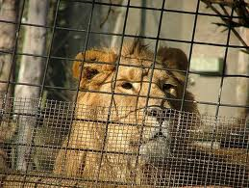 **Zoo vs. Jungle** 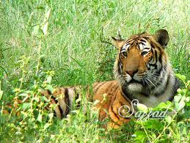

Please write as many things that you can about what life is like in each of these places…

|  |  |
| --- | --- |
| ZOO | JUNGLE |
|  |  |

**Public Good** [**https://youtu.be/CW7aWKXB5J4**](https://youtu.be/CW7aWKXB5J4) **N S P E**

The economies of Canada and the U.S. are similar in many ways, but they developed from different starting point. Their starting points involve different answers to this fundamental question of values:

**“THE PUBLIC GOOD”**

What does this mean? ____________________________________________________________________________________________________________________________________________

Compare how Canada & the USA differ in their views about “the public good”.

|  |  |
| --- | --- |
| **CANADA: COOPERATION** | **USA: INDIVIDUALISM** |
| • <https://youtu.be/fHAOWLhrxhQ> | • <https://youtu.be/p890hIa1w9k> |

Why do you think we have answered the question differently at different points in our histories? ____________________________________________________________________________________________________________________________________________

____________________________________________________________________________________________________________________________________________

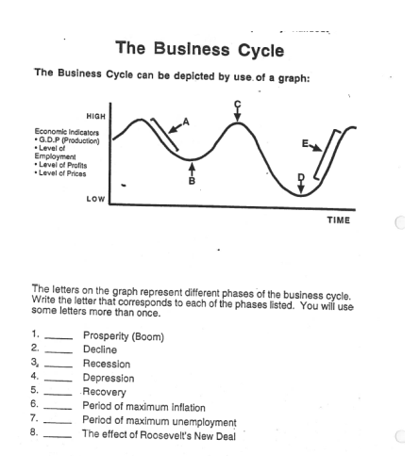**The Business Cycle**

As you have seen, the free market economy does not grow at a constant rate. Instead, it goes through a continuing series of **“booms”** and **“busts”** called the **business cycle**.

A boom is a period of **prosperity**. There is a high level of **employment** and consumers spend freely. Wages and profits are rising and the total level of **production** (as measured the **Gross Domestic Product**) is high. During these periods, economies may face the problem of **inflation**. Inflation refers to rapidly increasing prices due to high spending; it is a problem mainly because it can cause serious difficulties for people who are living on **fixed incomes** such as pensions.

A bust is a period of economic **decline** and crisis. As the level of production decreases, workers are laid off and **unemployment** rises. Consumer spending falls and, as a result, prices and profits drop. A mild and short lived bust is called a **recession**; a longer and more severe period of decline is called a **depression**.

Governments have tried to even out the boom and bust cycle by changing the level of their spending and by changing the supply of money in the economy. Despite their efforts, the business cycle continues to affect free market economies.

**Match Questions**

Match the terms with a correct description.

1. ___ The principle that economics decisions should be made by people buying goods.
2. ___Where and when buyers meet.
3. ___The “invisible hand” that guides producers to meet the needs of consumers.
4. ___The force that helps keep prices low and quality high.
5. ___The total amount of a product that business will offer for sale at a given price.
6. ___The point at which supply and demand are equal.
7. ___A condition that exists when the supply of a good is greater than the demand or that good.
8. ___The tools, factories, and financing needed to produce a good.
9. ___The basic problem that must be faced by every economic system.
10. ___The problem that exists when the price of a good is set below the market price.

**Word List**

1. Equilibrium
2. Surplus
3. Shortage
4. Capital
5. Profit
6. Consumer sovereignty
7. Scarcity
8. Competition
9. Market
10. Supply

**Crown Corporations N S P E**

**Use the following website to answer questions about Crown Corporations…..**

[***http://www.mapleleafweb.com/features/crown-corporations-canada***](http://www.mapleleafweb.com/features/crown-corporations-canada)

1. **What are crown corporations? Who owns them?**
2. **What are private corporations? Whose interests are they designed to serve?**
3. **Why are “crown” corporations referred to as such? Who are they managed by?**
4. **Provide the four main purposes of the crown corporation and give a brief description of each.**
5. **Provide two examples of prominent crown corporations in Canada and give a description of what they are.**
6. **Discuss two arguments for privatization.**
7. **Define government corruption and patronage.**
8. **Discuss two arguments against privatization.**

***Homework***

***In the space below answer the following question…..***

***Based on your readings, should Canada have crown corporations? Why, or why not? Use at least two examples to defend your argument.***

***_____________________________________________________________________***

***_____________________________________________________________________***

***_____________________________________________________________________***

***_____________________________________________________________________***

***_____________________________________________________________________***

***_____________________________________________________________________***

***_____________________________________________________________________***

***_____________________________________________________________________***

***_____________________________________________________________________***

***_____________________________________________________________________***

***_____________________________________________________________________***

How do market economies work? Competition & Monopoly

*Instructions: Use the information in pages 212-213 to answer the following questions.*

1. What are some factors that affect competition?
2. How are you impacted by competition? In other words, how do stores in a mall try to influence your ideas about what you need and want? How does this connect to the variety and quality of services a mall offers?
3. In an economic system, a monopoly is the opposite of competition? Provide a definition for monopoly.
4. Provide an example of a monopoly in Canada. What is the purpose of this specific monopoly?

**Economics: A Review of Basic Concepts N S P E**

Using your notes and your textbook, complete the following passage by filling in the blanks using the Word List below. Each word may only be used once.

**WORD LIST:**

**traditional centrally planned wants land**

**capital labour whom free market**

**mixed resources non-renewable decisions**

**economic system mental entrepreneurship renewable**

**scarcity how**

People have unlimited ____________________, but society cannot meet all of these because its ____________________ are limited. This problem exists in all societies and can be summed up in a single word: ____________________. To deal with this problem, every human society has an ____________________ ____________________, some way of making ____________________ about how its resources should be used. Its purpose it to answer three basic economic questions concerning the use of resources:

1. What goods should be produced?
2. ____________________ should these goods be produced?
3. For ____________________ should these goods be produced?

There are three general types of resources, or *factors of production*, that are used in producing a good or service. The human effort needed to create something of worth is called ____________________. This includes both physical and ____________________ effort. The tools, facilities and financing used in production are referred to as ____________________. ____________________ is the term used by economists to refer to all useful items found in the environment. Some materials are available in limited quantity. Once used up, these ____________________ resources are gone forever. Others will regenerate if harvested wisely, they are called ____________________ resources. Some economists say that ____________________, the willingness to take risks and the ability to organize a business, is so important that it should also be viewed as a basic economic resource.

There are several different ways of deciding how to answer the three basic economic questions. A ____________________ economy is one in which decisions are made on the basis of what was done in the past. When the government makes all important economic decisions it is said to operate a ____________________ ____________________ economic system. A ____________________ ____________________ economic system exists when buyers and sellers make all economic decisions for themselves. In reality, all real world economic systems are ____________________ economies because they combine aspects of these different systems.

**Consumerism Notes**

Consumer Sovereignty – the decisions of consumers to buy or not to buy determines which products and services that will survive in the marketplace.

In a market economy, the demand by consumers determines which companies succeed or fail. If consumers decide they no longer want these goods, companies will either disappear or start making and selling something else.

Fad – something many people are interested in for a short period of time; a craze or rage.

Examples of Fads – Hula Hoop, Furbies, Tickle Me Elmo, Saddle Shoes, Beanie Babies

Ralph Nader – published a book called “Unsafe At Any Speed” about how the General Motors Corvair was an unsafe car in the 1960’s. Ralph became a “Consumer Advocate” who looks out for people. He demanded that the government place rules and regulations to control producers – as producers were simply interested in profits, not public safety. Producers were strongly opposed to more government involvement in a market economy.

Rights and Responsibilities of Consumers:

1. Safety
   * the right to safety led to laws to regulate food, clothing, drugs, cosmetics, and tires.
2. Information
   * laws supporting information were directed against false advertising and true interest rates and proper labels showing ingredients and nutritional values in food products.
3. Choice
   * the right to choose dealt with antitrust legislation – avoiding monopolies.
4. Be Heard

* Having the right to be heard meant that consumers had the freedom to express their concerns which resulted in the creation of a special government agency to promote consumer concerns.

Arguments for Consumer Control:

* Consumers are free to buy what they want. Sellers cannot force anyone to buy something. Consumers only get what they want.
* Consumers shop wisely for the best and cheapest product or service; thus only the best and lowest-priced items will survive in a free market.
* Consumers have political power. They are voters so they can get their elected government to force changes on producers if necessary.

Arguments for Producer Control:

* Producers are usually a small group so they can easily get together to set any price they want; that is, they can form a monopoly.
* Producers can advertise in the mass media to create wants and needs in consumers. This advertising can mislead or confuse consumers to buy goods and services they do not need.
* Producers have political power. Politicians will tend to listen more to a few rich producers than a large group of poor and disorganized consumers.

**What affects the impact of consumerism on the economies of Canada & the USA?**

Read pages 257 – 264 and complete the following activities.

1. What is a boycott? ______________________________________________________________ ______________________________________________________________

2. a) Give an example of something you or someone you know has boycotted.

______________________________________________________________

b) Why did they boycott this product? ______________________________________________________________ ______________________________________________________________

3. Read “Buying on a Budget” on pages 258-260.

a) What influences John’s behavior as a consumer? ______________________________________________________________ ______________________________________________________________

b) How does his income affect his decisions? ______________________________________________________________ ______________________________________________________________

4 a) What do you have to budget for in your daily life? ______________________________________________________________ ______________________________________________________________

b) Identify an item that you would like to buy but haven’t yet. __________________________________

c) What plan do you have in place to buy it? ______________________________________________________________ ______________________________________________________________

5. Read page 261 and explain how prosperity differs regionally. ______________________________________________________________ ______________________________________________________________

______________________________________________________________ ______________________________________________________________

6. a) What does GDP stand for? _____________________________________________

b) What does it mean? __________________________________________________

7. Identify how each group has been empowered by consumerism.

a) Greenpeace ______________________________________________________________ ______________________________________________________________

______________________________________________________________ ______________________________________________________________

b) Animal Rights Groups ______________________________________________________________ ______________________________________________________________

______________________________________________________________ ______________________________________________________________

c) Human Rights Groups ______________________________________________________________ ______________________________________________________________

______________________________________________________________ ______________________________________________________________

8. Explain what was being boycotted and why.

a) By Louis-Joseph Papineau ______________________________________________________________ ______________________________________________________________

______________________________________________________________ ______________________________________________________________

b) By the Lubicon Lake Cree ______________________________________________________________ ______________________________________________________________

______________________________________________________________ ______________________________________________________________

**CONSUMERISM**

**How does consumer behavior affect quality of life for individuals and groups in Canada & the USA?**

Read pages 242 - 256 and complete the following activities.

1. Fill in the chart below with regards to identity.

|  |  |  |  |
| --- | --- | --- | --- |
| **Grade 9 Students** | **Their view on how clothing shapes their identity.** | **What does this say about their behavior as a consumer?** | **How does this view compare with yours?** |
| **Jordan Stang** |  |  |  |
| **Thao Duong** |  |  |  |
| **Mackenzie Kerman** |  |  |  |
| **Meagan McIntosh** |  |  |  |
| **You** |  |  |  |

**Cartoons about Consumerism**

Use page 256 of your textbook to complete the following.

|  |  |  |
| --- | --- | --- |
|  | **CARTOON #1 (left)** | **CARTOON #2 (right)** |
| **Factor Influencing Behavior** | **•** | **•** |
| **Links between Consumerism & Quality of Life** | **•**  **•** | **•**  **•** |

**Draw Your own Cartoon representing your own ideas about factors that influence consumer behavior.**

|  |
| --- |
|  |

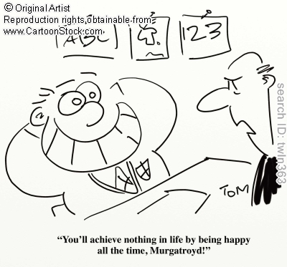 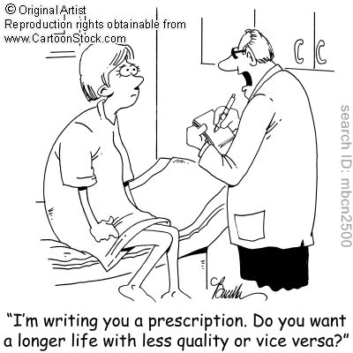

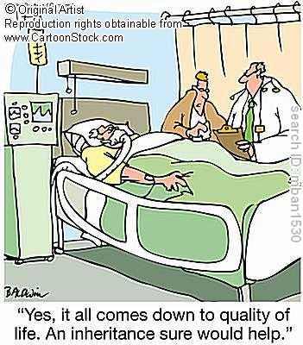 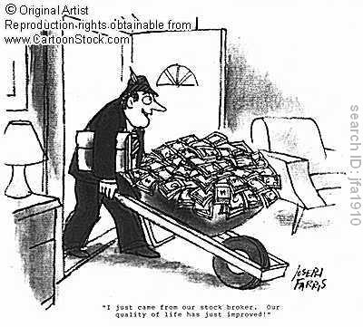

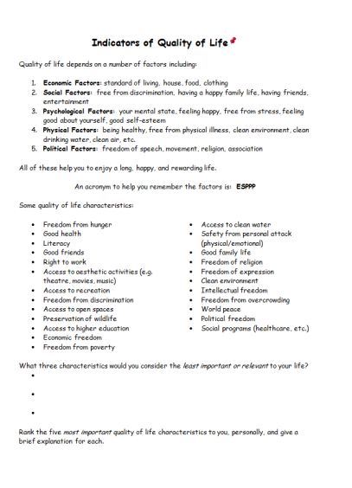

**Comparing Quality of Life**

|  |  |  |
| --- | --- | --- |
|  | **Positive Factors** | **Negative Factors** |
| **José’s Life** |  |  |
| **Emma’s Life** |  |  |

I conclude that José has the better quality of life because____________.

Emma

**José**

Turning over on the woven sleeping mat, José bumped into his younger brother. He could see the early morning light through the cracks in the stick wall of his family’s home. The sticks broke easily but were a type of wood that the termites wouldn’t eat.

José could hear his mother feeding the chickens in the yard. Gently raising the thin bedsheet that kept the bugs off at night, José sat up and climbed over Salvador and his tiny sister Rosita. Careful not to wake them, he replaced the sheet and stepped onto the dirt floor.

This was José’s favourite time of the day and, as he stepped outside, he breathed deeply the clean morning air. When his mother saw him, she smiled. Her smile had not always been so sad. She had been troubled ever since his older brother Juan was taken away by the police and his father left to work in the mountains. He tried not to think about it. He was nine years old and the oldest child at home so his mother needed him to be strong.

He smiled at his mother and walked to the well on the other side of the yard that he had helped his father and Juan dig. Only four tugs on the rope brought up a bucket of water. He felt blessed not to have to walk the two kilometres for dirty creek water or the five kilometres to the river like most of the villagers. In 20 minutes he had enough water for the chickens, pigs, today’s washing and for breakfast. Then he watered the chili pepper plants. The thin green peppers were getting longer.

“Mama, mama,” came the call from inside the hut as four-year-old Rosita and seven-year-old Salvador jumped up off the sleeping mat and ran out of the hut. Both wore the wonderful hats their father had given them for Christmas.

Mother made coffee and hot salted tortillas for breakfast. Eating silently, watching his family, José’s chest filled with warmth. Thinking about the day, he remembered they had a little cheese to put on the tortillas they would have for dinner that night. He could hardly wait. “It is another day and more good things are going to happen,” he thought as he and Salvador picked up their machetes and headed off to the coffee plantation.

This week they were cutting down all the weeds to get ready for planting. It was harder than burning them, but it took longer and gave them more money. Maybe mama could buy a coconut with the extra money they would earn.

After chores were done on the coffee plantation, José had an hour before dinner to work with the school teacher. José hoped he would hear more of the story about the girl in the city and practise his writing. It was fun to help the little ones and listen to them read. Hearing Salvador read aloud made him proud. But José knew that, as much as they all might want to go on in school, learning to read and write and do simple arithmetic was all the schooling that anyone in his family was going to have. It would not be long before he would have to leave home to find work to help support the family.

However, it was only three weeks until Holy Week when he could wear his new white cotton shirt and listen to the choir sing. Holy Week was always a special time in Brazil, especially Easter Sunday, the last day of the week-long events. Maybe his father and uncle would come back and sing his favourite song after dinner that night. It was so exciting to see everyone dressed in their best shirts and dresses singing and dancing.

**Emma**

“I hate you. You’re such an idiot!” The back door slammed loudly. Emma opened her eyes quickly and pulled up her soft comforter. Her heart was beating fast and she had a knot in her stomach. It was her older sister who had yelled and slammed the door.

“Lazy head, out of bed!” her father shouted from the bottom of the stairs. Heavy footsteps quickly moved through the house and then the front door opened and slammed shut. The car started and with a screech pulled away. Dad must be late for work. He often seemed angry now. Emma remembered happier times when he helped her with her homework and they would go to basketball games together. She wondered if it would ever be like that again.

Emma looked across the room and realized she had left her computer on all night. She squinted as the bedroom light glared into her eyes. Except for the noise of the computer, the house was quiet.

Sitting up on the edge of the bed she noticed that her hoody was all twisted around her neck. She pulled it loose and untangled her hair. Falling asleep late with all her clothes on was becoming a habit. Stepping across the room her foot caught some pants that were heaped with clothes across the floor. “When will Dad show me how to use the washing machine?” she thought to herself.

Walking past the family room, she saw that the giant-screen television was on but the sound was off. The time blinked 12:00 on the DVD player. A pizza box was on the couch with a plate and glass on it. Turning up the sound, she sat down. “So, what can you tell us about being bullied everyday?” asked the host of the talk show.

“I could be on this show,” she said to herself. The knot came back into her stomach as she thought of the girls who were two grades ahead of her and who threatened her every day.

The growling in her stomach reminded her she hadn’t eaten since those two pizza pops after school yesterday. She opened the big fridge. “No milk, no juice …!” She found the last pizza pop in the freezer and stuck it in the microwave. The cappuccino machine had coffee left from yesterday. Picking out a mug from the dirty dishes, she poured the cold coffee into it. Removing the pizza pop from the microwave, she replaced it with the coffee and after the beep took them both down the hall to the family room to watch television.

The house seemed empty now that mom had moved back to nana and poppa’s. When was the last time she had seen her? Almost two months now. She hoped it wouldn’t be long before she could spend a weekend with her at nana and poppa’s.

“What time is it?” she wondered aloud. The clock on the stove said 8:35 a.m. “I’m late!” Quickly finishing breakfast she stuck her cell phone in her pocket and headed out the door. The older girls would already be at school so she wouldn’t have to worry about them until break time.

“My social assignment!” she remembered, and she grabbed it and ran down the stairs. Emma really liked her social teacher this term. Mrs. Cavendish was really helpful and treated her like she cared about her. “I really want to do better this term. If I can pull up my average, then next year I might be able to change schools. Maybe more of the teachers will be like Mrs. Cavendish. Maybe then things will change.”

**Chapter #7 – Consumerism**

**Project – Convincing a Consumer with Advertising**

**INSTRUCTIONS**

Invent a product/service and then advertise it, making sure to identify all six factors listed in the textbook (p.255). You need to make an advertisement that touches on all six factors in attempting to convince your consumer to purchase the product/service. The project is to be drawn onto an 11” x 17” piece of paper. You have been asked to create a project that will interest the youth of Canada and will be placed into teen magazines across the country.

You will have 2 in-class periods to complete your project.

**ASSESSMENT PROCEDURE**

* Advertisement detailing the 6 factors.......... /6

(Bandwagon effect, emotional appeal, glittering generalities, plain folks appeal, testimonials, & scientific appeal)

* Quality of Advertisement Presentation......... /6

(neatness, fully colored, spelling, eye-catching, target audience