Social 9
Name: ___________________________

Class: _______________

[Canada: Collective Rights]

Vocabulary:
Define the following terms using the textbook glossary. Those terms underlined will need a dictionary to define. Page numbers will assist with understanding how the context words are being used.

- affirm –

- collective identity –

- collective rights –

- First Nations –

- Indian –

- Sovereignty –

- Annuity –

- Reserve –

- Entrenching –

- Patriate –

- Assimilate –

- Ethnocentrism –

- Indian Act –

- Anglophone –

- Francophone –

- Official language community –

- Official language minority –

- Publicly funded –

- Inherent rights –

- Scrip –

- Autonomy –

Collective Rights Legislation N S P E
Use the information found on page 122 to complete the diagram below.

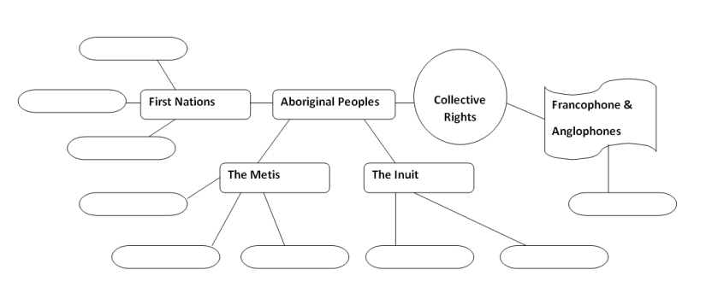
- What are Collective Rights?

- Why do some people have collective rights and others not

Responsibilities of Citizenship: /25
This is a summative assignment. Use your text pages 124 - 135 to answer the following questions in point-form.
- What are the Numbered Treaties? (4 points)

- What are the terms of Treaties 6, 7 and 8 and what dates were they established? (6 points)
Treaty 6
Treaty 7
Treaty 8

- Using page 130, what was the Canadian Government’s view of the Indian Act? (1 point)

- What is a law versus a policy? (2 points)

- What did the Davin Report in 1879 recommend? (2 points)

- What were the 4 main aims of the Indian Association of Alberta in 1939? (4 points)

- When were the following Land Agreements made and what did they do? (6 points)
Agreement: | Date: | Concerned with:
Nunavut Land Claims Agreement

Sahtu Dene and Metis Comprehensive Land Claim Agreement
Nisga’a Final Agreement

Collective Rights: A Summary N S P E
Create a summary for each of the major categories using pages 120 – 159.
Collective Rights and Official Languages
Collective Rights and the First Nations

What are Collective Rights
Collective Rights and the Metis

Collective Rights and the Metis /10
Using pages 152 – 159 complete the following timeline. Highlight those events that you believe were most important to the Metis and the development of their collective rights.
1938
1896 - 1910
1885
1875 - 1879
1869 - 1870
1869
2004
1938

1940 - 1960
1982
1990
2003
2004

- In what ways has the Canadian Charter of Rights and Freedoms fostered recognition of collective rights in Canada?
- To what extent should federal and provincial governments support and promote the rights of official language minorities in Canada?
- How does the Indian Act recognize the status and identity of Aboriginal peoples?
- How does legislation such as Treaty 6, Treaty 7 and Treaty 8 recognize the status and identity of Aboriginal peoples?
- How do governments recognize Métis cultures and rights through legislation (i.e., treaties, governance, land claims, Métis Settlements in Alberta)?

